TEST PLAN

Creating a test plan is crucial for ensuring the quality and reliability of a software system. Here's a basic outline of what a test plan might include for a Spring Boot application:

1. **Introduction**:
   * Overview of the test plan.
   * Objectives and goals of testing.
   * Scope of testing (which parts of the application are covered).
2. **Test Strategy**:
   * Approach to testing (e.g., manual vs. automated, black-box vs. white-box).
   * Test levels (unit testing, integration testing, system testing).
   * Testing techniques (functional testing, performance testing, security testing).
   * Tools and technologies used for testing.
3. **Test Environment**:
   * Description of the testing environment (e.g., hardware, software, network configuration).
   * Configuration management (versions of dependencies, database configurations).
   * Setup and installation instructions for the testing environment.
4. **Test Cases**:
   * Detailed test cases for each functional requirement of the application.
   * Each test case should include:
     + Test case ID and name.
     + Description of the test scenario.
     + Preconditions.
     + Steps to execute the test.
     + Expected results.
     + Actual results (to be filled in during execution).
     + Pass/fail status.
   * Test cases should cover:
     + Positive scenarios (expected behavior).
     + Negative scenarios (error handling, edge cases).
     + Boundary conditions.
5. **Test Execution**:
   * Test execution schedule (timeline for executing different types of tests).
   * Responsibilities of testers and stakeholders.
   * Test data preparation (sample data, test databases).
   * Procedures for executing tests and recording results.
   * Defect tracking and management (tools used, workflow for reporting and resolving defects).
6. **Test Reporting**:
   * Formats for test reports (e.g., daily status reports, test summary reports).
   * Metrics and measurements collected during testing (e.g., test coverage, defect density).
   * Criteria for evaluating test results and determining readiness for release.
7. **Risks and Mitigation**:
   * Identification of potential risks to the testing process or the application.
   * Mitigation strategies for addressing risks.
   * Contingency plans for handling unexpected issues during testing.
8. **Dependencies**:
   * External dependencies on other systems or components.
   * Dependencies on test data, environments, or resources.
9. **Approval**:
   * Sign-off process for approving the test plan.
   * Stakeholders responsible for approving the test plan.
10. **Appendices**:
    * Glossary of terms.
    * References to relevant documentation or resources.

This outline provides a structured approach to creating a test plan for a Spring Boot application, ensuring that testing activities are well-defined, organized, and aligned with the goals and requirements of the project.

Test Strategy

It seems like you're referring to "test strategy," which outlines the overall approach and methodologies for testing a software system. Here's a breakdown of what a test strategy might entail:

1. **Introduction**:
   * Overview of the test strategy document.
   * Purpose and objectives of testing.
   * Scope of testing (which parts of the system are covered).
2. **Testing Objectives**:
   * Clearly defined goals and objectives for testing.
   * Alignment with business goals and project requirements.
   * Prioritization of testing activities based on criticality and risk.
3. **Testing Approach**:
   * Description of the overall testing approach (e.g., waterfall, agile, DevOps).
   * Selection of testing methodologies (e.g., black-box, white-box, grey-box).
   * Consideration of factors such as project timeline, resources, and constraints.
4. **Test Levels**:
   * Identification of different levels of testing (unit testing, integration testing, system testing, acceptance testing).
   * Definition of entry and exit criteria for each test level.
   * Allocation of responsibilities among different testing teams or roles.
5. **Test Types**:
   * Description of different types of testing (functional, non-functional).
   * Consideration of specific types of testing such as performance testing, security testing, usability testing, etc.
   * Selection of appropriate tools and techniques for each type of testing.
6. **Test Automation**:
   * Strategy for test automation (when and what to automate).
   * Selection of test automation tools and frameworks.
   * Guidelines for writing and maintaining automated tests.
7. **Test Data Management**:
   * Approach to test data generation, provisioning, and management.
   * Consideration of data privacy and security requirements.
   * Techniques for creating realistic and diverse test datasets.
8. **Environment Setup and Management**:
   * Strategy for setting up and configuring testing environments.
   * Consideration of hardware, software, and network requirements.
   * Management of test environments (versioning, provisioning, cleanup).
9. **Defect Management**:
   * Process for reporting, tracking, and resolving defects.
   * Defect classification, prioritization, and escalation guidelines.
   * Integration of defect management with project management tools.
10. **Metrics and Reporting**:
    * Identification of key metrics for measuring testing effectiveness (e.g., test coverage, defect density, test execution progress).
    * Reporting mechanisms and frequency (e.g., daily status reports, test summary reports).
    * Communication channels for sharing test results and insights with stakeholders.
11. **Risk Management**:
    * Identification and assessment of project risks related to testing.
    * Mitigation strategies for addressing high-priority risks.
    * Contingency plans for handling unexpected issues during testing.
12. **Training and Resource Planning**:
    * Training needs for testing team members.
    * Resource allocation and planning for testing activities.
    * Identification of skills and expertise required for successful testing.
13. **Review and Approval**:
    * Process for reviewing and approving the test strategy document.
    * Stakeholders responsible for reviewing and signing off on the document.
14. **Appendices**:
    * Glossary of terms.
    * References to relevant standards, guidelines, or documentation.

By developing a comprehensive test strategy, teams can ensure that testing efforts are well-planned, organized, and aligned with project goals, ultimately leading to higher-quality software products.

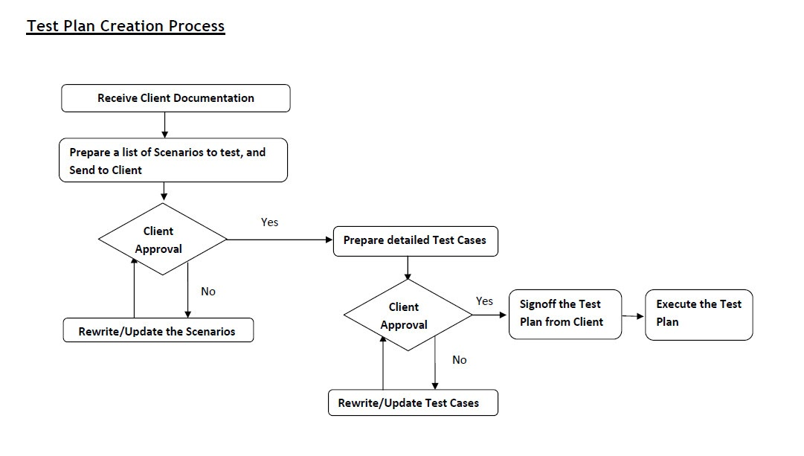

THANK YOU